PRESS RELEASE

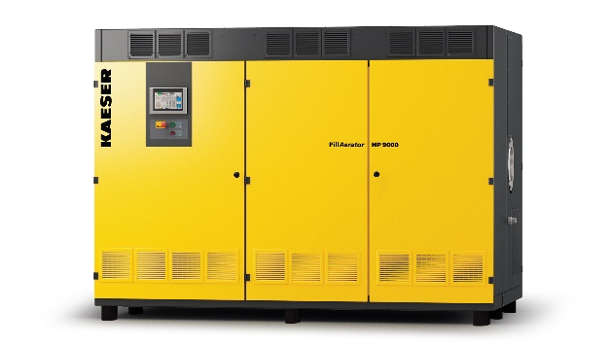
9/16/2019
Kaeser introduces turbo blowers for wastewater treatment and other low-pressure applications
Download a high resolution image here.
Press Information Center
Contact us for contributions

FOR IMMEDIATE RELEASE
KAESER COMPRESSORS ADDS TURBO BLOWERS
Kaeser expands blower line with PillAerator acquisition
With the July 2019 acquisition of PillAerator GmbH, Kaeser has added turbo blowers to its line of rotary lobe and rotary screw blowers. This action significantly expands Kaeser’s offering for the water/wastewater market and other large flow, low pressure applications including bioreactors and flue gas desulphurization.
“The PillAerator acquisition was an excellent fit due to both companies’ high standards for product quality, innovative design, and energy efficiency,” said Stephen Horne, Blower Product Manager for Kaeser USA. “PillAerator’s simple and reliable design has a proven record for performance with units operating around the world, and we are already getting a lot of interest from our US wastewater partners.”
Available with flows from 4,700 up to 10,000 cfm, PillAerator blowers feature gas-tight, permanent magnet motors with active magnetic bearings, integrated frequency converters and closed-loop water cooling. Units are compact and quiet plus advanced controls offer full interoperability with SCADA systems.
For more information visit us.kaeser.com/turboblowers.
About Kaeser Compressors, Inc.: Kaeser Compressors is a leader in reliable, energy efficient compressed air equipment and system design. We offer a complete line of superior quality industrial air compressors as well as dryers, filters, SmartPipe™, master controls, and other system accessories. Kaeser also offers blowers, vacuum pumps, and portable gasoline and diesel screw compressors. Our national service network provides installation, rentals, maintenance, repair, and system audits. Kaeser is an ENERGY STAR Partner.

###

