Kaeser Compressors, Inc.
PO Box 946 Fredericksburg, VA 22404 USA
Phone: (540) 898-5500 us.kaeser.com

Press Contact: Michael Camber • (540)369-8015
pr.us@kaeser.com

05/22/2024
FOR IMMEDIATE RELEASE

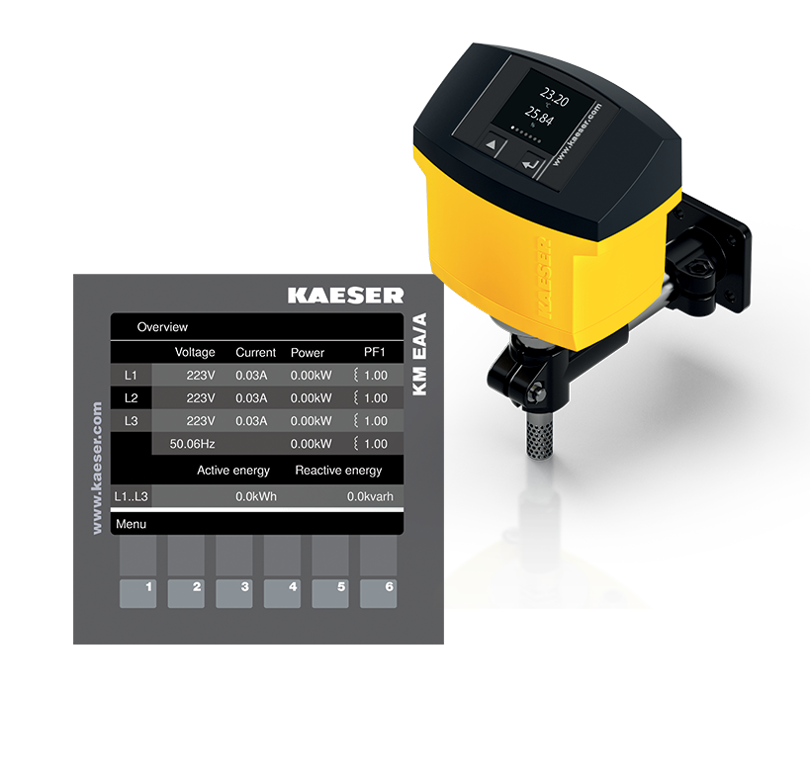 | KAESER MEASUREMENT TECHNOLOGY is a suite of intelligent sensors to continuously monitor key  performance indicators throughout the entire compressed air system.  Download a high-resolution image here.
Kaeser Measurement Technology (KMT)

Kaeser Measurement Technology (KMT) enhances compressed air system management

Kaeser Compressors, a leading provider of innovative compressed air solutions, has launched the new Kaeser Measurement Technology (KMT), a comprehensive suite of intelligent sensors designed to deliver real-time insights and optimize compressed air system performance.

“In today’s data-driven manufacturing landscape, effective compressed air system monitoring is critical for maximizing efficiency and minimizing costs,” said Timothy Hitzges, System Integrator at Kaeser Compressors. “The KMT empowers our customers to gain a deeper understanding of their compressed air operations, enabling them to make data-driven decisions that optimize performance and reduce energy consumption.”

Key Features and Benefits of Kaeser Measurement Technology:

- Universal connectivity: KMT devices leverage Power over Ethernet (PoE) for simplified installation and reduced cabling costs. Seamless integration with the Kaeser Sigma Network (SNW) ensures true IIoT (Industrial Internet of Things) capabilities.
- Unmatched versatility: KMT devices can be applied across various applications, including high-pressure booster systems. This eliminates the need for multiple vendors and simplifies system management.
- Real-time data streaming: The Energy Analyzer and Flow Analyzers boast the ability to stream a multitude of data points in real-time, providing unparalleled insights into system operation.
- Actionable insights: KMT goes beyond data collection. Specific data points can trigger automated actions within the compressed air station. For instance, with an additional logic controller and wiring the Ambient Analyzer can monitor room temperature and automatically adjust inlet or exhaust dampers to maintain optimal operating conditions.
- Superior monitoring and control: KMT data can be seamlessly integrated with the Kaeser Sigma Air Manager 4.0 (SAM 4.0) for comprehensive system monitoring and control. Alternatively, Modbus TCP and Modbus RTU connectivity allows for integration with a customer’s existing industrial and building automation system.

Enhanced Decision-Making with KPIs

“While traditional compressed air monitoring solutions often offer limited data points via a single 4-20mA output, KMT delivers a wealth of data points that paint a complete picture of compressed air system health,” said Hitzges. “By feeding this data into the SAM 4.0, customers gain valuable key performance indicators (KPIs) that empower them to make informed decisions about their compressed air operations.”

For more information, visit us.kaeser.com/kmt. To be connected with your local authorized Kaeser representative, please call (877) 417-3527.

###

About Kaeser Compressors, Inc.: Kaeser Compressors is a leader in reliable, energy efficient compressed air equipment and system design. We offer a complete line of superior quality industrial air compressors as well as dryers, filters, SmartPipe™, master controls, and other system accessories. Kaeser also offers blowers, vacuum pumps, and portable gasoline and diesel screw compressors. Our national service network provides installation, rentals, maintenance, repair, and system audits. Kaeser is an ENERGY STAR Partner.

