Kaeser Compressors, Inc.
PO Box 946 Fredericksburg, VA 22404 USA
Phone: (540) 898-5500 us.kaeser.com

Press Contact: Michael Camber • (540) 369-8015
pr.us@kaeser.com

08/12/2024
FOR IMMEDIATE RELEASE

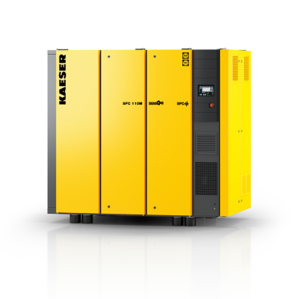 | SFC 110M with flows up to 742 cfm and 150 HP permanent magnet motor.  Download a high-resolution image here.

NEW SFC 110M EXTENDS SERIES

Kaeser has launched the SFC 110M variable frequency drive compressor with a 110 kW (150 hp) permanent magnet motor and flows up to 742 cfm.

Kaeser Compressors’ new SFC 110M extends the SFC 45 to 90M series to 150 hp with an enhanced flow range of 103 to 742 cfm at 100 psig. The SFC 110M features a new Sigma Profile™ airend driven by a permanent magnet motor. This combination boosts energy performance and flow with a smaller physical footprint and less heat. This model inherits all the features of the current series such as the speed controlled fan with a brushless DC motor for better cooling and the Sigma Control 2 for superior condition monitoring and external communication capabilities. Other key features of the SFC110M include:

- Improved energy performance with flow increases up to 20% and specific power below 18kW/100 cfm.
- Improved maintenance access for faster service including fluid changes and valve maintenance, ensuring minimal downtime and maximum productivity.
- Optional integrated refrigerated dryers with improved service access.
- Reduced environmental impact from lower energy usage, an eco-friendly fluid filter element, and low GWP refrigerant R-513A on models with integrated dryers.

"The introduction of the SFC110M to our product line underscores KAESER's commitment to innovation and sustainability," said Werner Rauer, Product Manager for Screw Compressors at Kaeser Compressors. "Our customers will benefit from enhanced performance, lower operational costs, and a reduced environmental impact, making the SFC110M a valuable addition to their operations."

For more information, visit us.kaeser.com/sfc. To be connected with your local authorized Kaeser representative, please call (877) 417-3527.

###

About Kaeser Compressors, Inc.: Kaeser Compressors is a leader in reliable, energy efficient compressed air equipment and system design. We offer a complete line of superior quality industrial air compressors as well as dryers, filters, SmartPipe™, master controls, and other system accessories. Kaeser also offers blowers, vacuum pumps, and portable gasoline and diesel screw compressors. Our national service network provides installation, rentals, maintenance, repair, and system audits. Kaeser is an ENERGY STAR Partner.

