PRESS RELEASE

10/30/2019
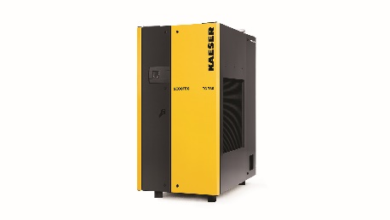
New TG Series SECOTEC™ dryer features climate-friendly R-513A refrigerant
Download a high resolution image here.
Press Information Center
Contact us for contributions

FOR IMMEDIATE RELEASE
New TG Series SECOTEC™ Refrigerated Dryers
Kaeser’s expanded SECOTEC™ refrigerated dryer line features five new models for larger compressed air systems.
The new TG series, with five models from 1340 to 3070 scfm, has been designed for consistent dew point control and energy efficiency under varying load conditions.
Kaeser’s innovative SECOPACK LS thermal storage system contains a phase-changing material (PCM) that is 98% denser than conventional storage media. Thermal energy is stored as the PCM cycles from a solid to a liquid state, enhancing energy efficiency. TG dryers also have the advanced R-513A refrigerant which has 60% lower global warming potential and decreases refrigerant weight significantly. These features make the SECOTEC TG units up to 60% lighter than other thermal storage dryers. Plus, these units have a smaller footprint, making them perfect for facilities where space is limited.
SECOTEC TG units feature a variable speed radial fan design that further enhances energy efficiency, extends fan life, and enables dryer exhaust ducting. A dedicated fan in the electrical cabinet provides cooling in high heat environments. With SIGMA CONTROL SMART, a micro-processor based controller which controls the thermal storage process, remote on/off control capability, and an optional Ethernet interface for connecting to a master control system, TG units can be easily integrated into plant operations and IIoT environments.
For more information, visit us.kaeser.com/cleanair. For more information or to be connected with your local authorized Kaeser representative, please call (877) 417-3527
About Kaeser Compressors, Inc.: Kaeser Compressors is a leader in reliable, energy efficient compressed air equipment and system design. We offer a complete line of superior quality industrial air compressors as well as dryers, filters, SmartPipe™, master controls, and other system accessories. Kaeser also offers blowers, vacuum pumps, and portable gasoline and diesel screw compressors. Our national service network provides installation, rentals, maintenance, repair, and system audits. Kaeser is an ENERGY STAR Partner.

###

