PRESS RELEASE

05/28/2019
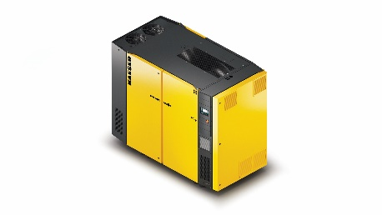
Redesigned VFD models in 60-125 hp offer greater efficiency and sustainability.
Download a high resolution image here.
Press Information Center
Contact us for contributions

FOR IMMEDIATE RELEASE
NEW VFD MODELS WITH IMPROVED EFFICIENCY
SynRM synchronous reluctance motors increase efficiency and service life for Kaeser SFC variable frequency drive compressors.
Kaeser Compressors has redesigned its Sigma Frequency Control (SFC) 45, 55, 75S, 90S and 110S compressors with advanced SynRM motor-drive combinations. These 60-125 hp units offer better part-load efficiency, longer service life, and reduced maintenance costs.
Developed in partnership with Siemens and specifically designed to work with Kaeser’s SFC models, the SynRM motor-drive combination achieves top tier IES2 classification. This results in better specific performance, especially in the part-load conditions that call for variable speed compressors.
They do not use aluminum, copper, or expensive rare earth metals in the rotors. Instead, they are made of electrical steel and feature a special profile. With this unique rotor design, the motors run cooler - resulting in lower bearing and winding temperatures and increased motor life. And because there are no magnets in the rotor, motor service is safer and easier.
To further enhance overall sustainability, SFC T models with the optional integrated refrigerated dryers have been upgraded with R-513A, a non-flammable, non-toxic advanced formulation refrigerant. R-513A has 56% lower global warming potential (GWP) compared to the current US standard (R-134A). This, combined with Kaeser’s advanced heat exchanger design, reduces refrigerant requirements without compromising dryer performance.
For more information, visit us.kaeser.com/SFC or call (877) 417-3527 to be connected with your local authorized Kaeser representative.
About Kaeser Compressors, Inc.: Kaeser Compressors is a leader in reliable, energy efficient compressed air equipment and system design. We offer a complete line of superior quality industrial air compressors as well as dryers, filters, SmartPipe™, master controls, and other system accessories. Kaeser also offers blowers, vacuum pumps, and portable gasoline and diesel screw compressors. Our national service network provides installation, rentals, maintenance, repair, and system audits. Kaeser is an ENERGY STAR Partner.

###

