Kaeser Compressors, Inc.
PO Box 946 Fredericksburg, VA 22404 USA
Phone: (540) 898-5500 us.kaeser.com

Press Contact: Michael Camber • (540) 684-9489
pr.us@kaeser.com

11/9/21
FOR IMMEDIATE RELEASE

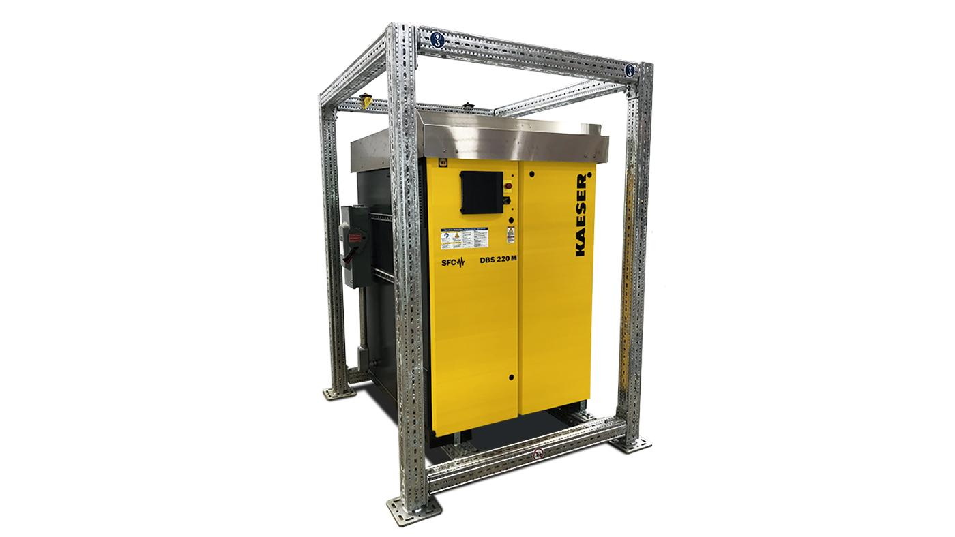 | Kaeser rental blowers offer efficiency and flexibility for a wide variety of applications.  Download a high-resolution image here.

Rental Rotary Screw Blowers Offer Efficiency and Flexibility

Kaeser’s rental blower program helps avoid downtime and maintain operations, AND helps you evaluate flow requirements prior to equipment purchase.

Announcing Kaeser’s new rental blower program! Whether you need to take a unit off-line for service without compromising operations, meet a temporary surge, or want to try out a new blower technology without spending capital, you can rent a portable rotary screw blower from Kaeser. Available in three sizes with oil-free flows ranging from 200 to 2309 cfm, these variable speed rotary screw blowers are extremely efficient and provide exceptional flexibility for a variety of low pressure applications.

All units feature our standard full enclosure with sound-proofing to promote safe working conditions and neighbor-friendly operation. They feature additional protection from rain and snow as well as auxiliary heaters in both the mechanical and electrical cabinets, making them suitable for outdoor installations in temperatures from 5 to 115° F. Each model has multiple control modes including pressure regulation, flow control (via panel-mounted potentiometer), and fixed speed.

Kaeser rental blowers are easily integrated into existing plant controls. Plus, if a new equipment purchase is the ultimate goal, the standard Sigma Control 2 will continuously record and store air demand and power usage to help size the permanent blower and calculate ROI from energy reduction.

For more information, visit us.kaeser.com/rentalblowers. For more information or to be connected with your local authorized Kaeser representative, please call (877) 417-3527

###

About Kaeser Compressors, Inc.: Kaeser Compressors is a leader in reliable, energy efficient compressed air equipment and system design. We offer a complete line of superior quality industrial air compressors as well as dryers, filters, SmartPipe™, master controls, and other system accessories. Kaeser also offers blowers, vacuum pumps, and portable gasoline and diesel screw compressors. Our national service network provides installation, rentals, maintenance, repair, and system audits. Kaeser is an ENERGY STAR Partner.

