PRESS RELEASE

11/21/2019
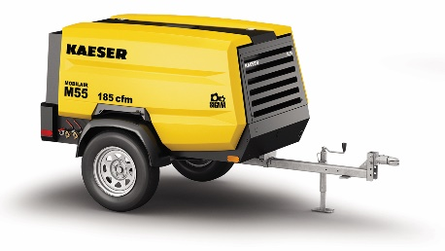
New M55PE delivers 185 cfm with Tier 4 Final engine.
Download a high resolution image here.
Press Information Center
Contact us for contributions

FOR IMMEDIATE RELEASE
KAESER ROLLS OUT NEW 185 CFM PORTABLE COMPRESSOR
The new M55PE is packed with features that increase reliability and safety while reducing downtime.
Kaeser Compressors’ new M55PE Mobilair™ compressor delivers 185 cfm at 100 psig—adjustable up to 125 psig. Built with reliability and durability in mind, these portable compressors are ideal for rental, construction, demolition, sand blasting, repair trucks, and other demanding applications.
The heavy-duty Tier 4 Final D1803CR-T Kubota diesel engine, coupled to the new Sigma 17G airend produces even more air with less horsepower. With its large 21 gallon fuel tank, the M55PE can run fully loaded for 8 hours before refueling.
The convenient eye-level, rear side instrument panel features the Sigma Control Smart electronic controller with intuitive user display, system monitoring and diagnostics. The cold start battery assures year round reliability and Kaeser’s anti-frost valve prevents tool freezing.
The galvanized steel chassis is topped with a scratch and dent-resistant polyethylene enclosure with wide-opening gull wing doors for easy access to maintenance points. The new spin-on air/oil separator greatly simplifies maintenance and reduces overall weight.
On the road, torsion bar suspension, larger wheels and tires, and LED lighting package ensure excellent handling and safety. For more information, visit us.kaeser.com/mobilair. For more information or to be connected with your local authorized Kaeser representative, please call (877) 417-3527.
About Kaeser Compressors, Inc.: Kaeser Compressors is a leader in reliable, energy efficient compressed air equipment and system design. We offer a complete line of superior quality industrial air compressors as well as dryers, filters, SmartPipe™, master controls, and other system accessories. Kaeser also offers blowers, vacuum pumps, and portable gasoline and diesel screw compressors. Our national service network provides installation, rentals, maintenance, repair, and system audits. Kaeser is an ENERGY STAR Partner.

###

