PRESS RELEASE

11/5/2018
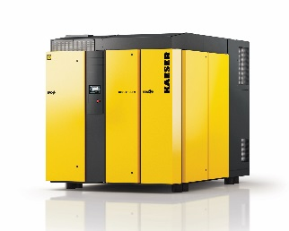
Kaeser’s new HBS screw blower packages for wastewater treatment and other low pressure applications
Download a high resolution image here.
Press Information Center
Contact us for contributions
FOR IMMEDIATE RELEASE
KAESER DOUBLES FLOW RANGE WITH NEW HBS SCREW BLOWERS
New models fill critical niche for small to mid-size treatment plants.
Kaeser Compressors has expanded its award-winning screw blower product line to include the new HBS packages. This series delivers 1412 to 5650 cfm at pressures up to 15 psig. With this expansion, Kaeser now offers our innovative screw blower technology to an even wider range of applications with up to 35% more efficiency than conventional packages. Kaeser screw blowers are designed for wastewater aeration and other low pressure applications where energy efficiency is critical.
HBS series blowers feature the renowned Sigma Profile airend, zero-loss direct drive technology and Sigma Frequency Control (variable frequency drive) for superior energy efficiency across a wider range of flows than comparable screw and turbo blowers.
Consistent with Kaeser’s other screw blowers, the HBS blowers arrive on site completely assembled with inlet filters, silencers, and full sound-proofing enclosure. This completely integrated design approach has time and again helped contractors and operators reduce installation time and errors that come with onsite integration.
HBS blowers feature Kaeser’s Sigma Control 2™ and a full complement of sensors to provide full visibility into its operational status, protect the machine, provide maintenance indicators and increase long-term reliability. Sigma Control 2 features broad communication capabilities including remote monitoring and email notifications for service and alarms. HBS units can be seamlessly integrated into plants that are implementing IoT, Industrie 4.0 or Water 4.0 strategies.
For more information on HBS or Kaeser’s entire range of screw blower packages, visit us.kaeser.com/screwblower. To be connected with your representative for additional information, please call (877) 417-3527.
About Kaeser: Kaeser is a leader in reliable, energy efficient compressed air equipment and system design. We offer a complete line of superior quality industrial air compressors as well as dryers, filters, SmartPipe™, master controls, and other system accessories. Kaeser also offers blowers, vacuum pumps, and portable gasoline and diesel screw compressors. Our national service network provides installation, rentals, maintenance, repair, and system audits. Kaeser is an ENERGY STAR Partner.
###

