PRESS RELEASE

10/22/2018
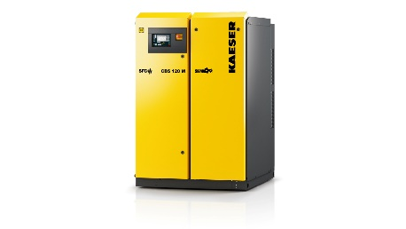
Kaeser’s new CBS screw blower packages for wastewater treatment and low pressure applications
Download a high resolution image here.
Press Information Center
Contact us for contributions
FOR IMMEDIATE RELEASE
NEW CBS SCREW BLOWERS DELIVER UNBEATABLE PERFORMANCE AND RELIABILITY
Integrated package blowers are up to 35% more efficient than conventional blowers.
Kaeser Compressors has expanded its award-winning screw blower product line to include the new CBS packages. This series delivers 93 to 448 cfm and pressures up to 15 psig. With this expansion, Kaeser now offers our innovative screw blower technology to an even wider range of applications with up to 35% more efficiency than conventional packages. Kaeser screw blowers are designed for wastewater aeration and other low pressure applications where energy efficiency is critical.
CBS series blowers feature the renowned Sigma Profile airend and high efficiency gear drive technology. They are available in both STC (wye-delta start) and SFC (Variable Frequency Drive) for superior energy performance –- and unsurpassed reliability. Frequency drive models have superior efficiency across a wider range of flows than comparable blowers.
Kaeser CBS screw blowers are shipped completely assembled with high efficiency motors, inlet filters, silencers, integral starters/drive, and a full complement of sensors for safe, reliable operation. The fully soundproofed enclosure is designed so that all maintenance access is in front and process connections are on the back for space-saving side-by-side installation. Sigma Control 2™ is standard on all models and features expanded communication capabilities including remote monitoring and email notifications for service and alarms. With Sigma Control 2, CBS units can be seamlessly integrated into plants that are implementing IoT, Industrie 4.0 or Water 4.0 strategies.
For more information on Kaeser’s entire range of screw blower packages, visit us.kaeser.com/screwblower. To be connected with your representative for additional information, please call (877) 417-3527.
About Kaeser: Kaeser is a leader in reliable, energy efficient compressed air equipment and system design. We offer a complete line of superior quality industrial air compressors as well as dryers, filters, SmartPipe™, master controls, and other system accessories. Kaeser also offers blowers, vacuum pumps, and portable gasoline and diesel screw compressors. Our national service network provides installation, rentals, maintenance, repair, and system audits. Kaeser is an ENERGY STAR Partner.
###

