PRESS RELEASE
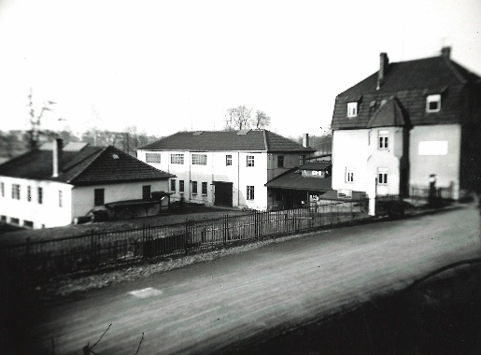
04/16/2019
Kaeser celebrates 100 years of innovation
Download a high resolution image here.
Press Information Center
Contact us for contributions

FOR IMMEDIATE RELEASE
KAESER CELEBRATES 100 YEARS OF INNOVATION
Kaeser Kompressoren is celebrating its 100 anniversary this year. Kaeser has grown into a global compressed air systems provider known for innovation, efficiency, and reliability.
Kaeser Kompressoren is celebrating its centennial year! Established in 1919 as a machine workshop in Coburg, Germany by Carl Kaeser, Sr., the company has grown into a leading compressor manufacturer and global compressed air systems provider. Its reputation and success is built on a firm foundation of innovation, ingenuity, efficiency and reliability.
Kaeser began manufacturing reciprocating compressors in 1948. Under the leadership of the founder’s son Carl Kaeser, Jr, Kaeser introduced the Sigma Profile rotary screw airend in 1975 which greatly advanced energy efficiency in compressed air systems. Launching the PC-based Sigma Control compressor controller in 1998 and introducing the comprehensive Sigma Air Manager in 2001, Kaeser led the industry in modern controls, paving the way for the integration of compressed air systems with Industrie 4.0 and advancing the industrial Internet of Things (IoT).
Today, Kaeser has over 6000 employees around the world, whose commitment, skill and drive for customer satisfaction are second to none.
In addition to major events planned in Germany, Kaeser subsidiaries and partners in over 100 countries throughout the world will be commemorating this important milestone with local events for employees and partners. An important part of the celebration will be a campaign of “100 Good Deeds.” Kaeser employees will donate their time and energy to support local charitable activities in their communities. These efforts mirror the Kaeser family’s long-standing commitment to the local communities where they do business.
A special 100 year anniversary website has been established to share a view into Kaeser’s rich heritage and the celebrations around the world. Visit https://www.kaeser-tradition-innovation.com/en.
About Kaeser Compressors, Inc.: Kaeser Compressors is a leader in reliable, energy efficient compressed air equipment and system design. We offer a complete line of superior quality industrial air compressors as well as dryers, filters, SmartPipe™, master controls, and other system accessories. Kaeser also offers blowers, vacuum pumps, and portable gasoline and diesel screw compressors. Our national service network provides installation, rentals, maintenance, repair, and system audits. Kaeser is an ENERGY STAR Partner.

###

