Kaeser Compressors, Inc.
PO Box 946 Fredericksburg, VA 22404 USA
Phone: (540) 898-5500 us.kaeser.com

Press Contact: Michael Camber • (540) 684-9489
pr.us@kaeser.com

2/7/2023
FOR IMMEDIATE RELEASE

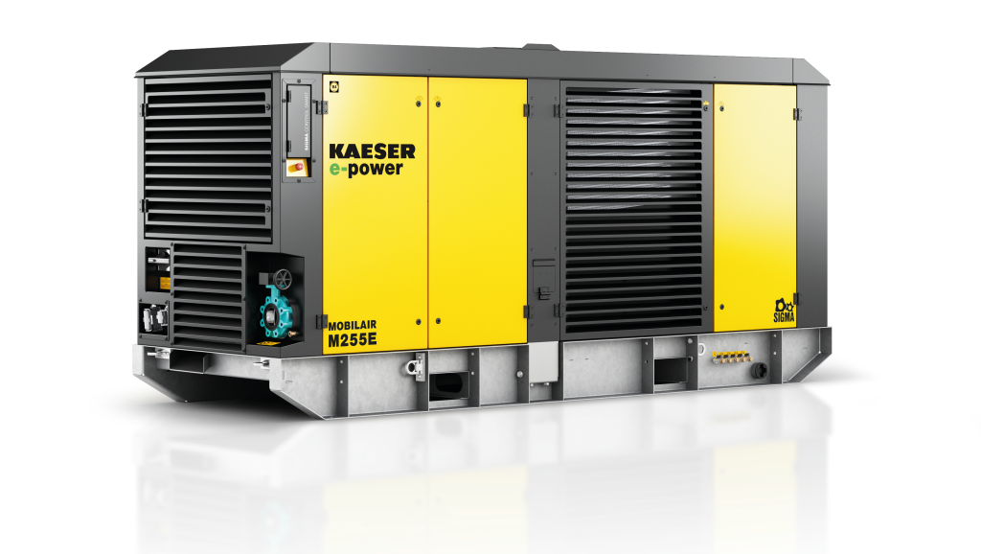 | The M250E/M255E skid-mounted compressor is fully electric and is designed for outdoor use in nearly any environment.  Download a high-resolution image here.

MOBILAIR Electric Portable Compressors

Kaeser’s new MOBILAIR M250E and M255E compressors offer the advantages of electric compressors in weatherproof, skid-mounted packages.

The M250E/M255E fully electric compressors are designed for outdoor operation without the need for additional weather protection. Providing 565-990 cfm with pressures from 87-200 psig, these skid-mounted units are perfect for either short-term or long-term rentals, back-up for industrial applications, or as a permanent installation even in the most challenging environments.

The M250E/M255E compressors feature a compact design with lashing and lifting eyes as well as forklift pockets for easy transport and placement on site. Standard equipment includes the new SIGMA CONTROL SMART offering intuitive control with maintenance reminders and real time operational data from a lockable, protected control panel. Pressure is adjustable to suit the application’s specific requirements. Additional features include Super Premium IE4 efficiency drive motor, standard modulation control, as well as a built-in aftercooler with condensate separator. Internal heaters extend standard operating temperature range from 14 to 104°F

Whether you need quality compressed air for construction, road and bridge repair, mining, tunneling, shipyards, or if there’s just no room inside of the plant, the M250E/M255E units offer rugged reliability, without refueling or emissions. For more information on these new units or our wide range of flexible compressed air options, visit us.kaeser.com/mobilair. To be connected with your local authorized Kaeser representative, please call (877) 417-3527.

###

About Kaeser Compressors, Inc.: Kaeser Compressors is a leader in reliable, energy efficient compressed air equipment and system design. We offer a complete line of superior quality industrial air compressors as well as dryers, filters, SmartPipe™, master controls, and other system accessories. Kaeser also offers blowers, vacuum pumps, and portable gasoline and diesel screw compressors. Our national service network provides installation, rentals, maintenance, repair, and system audits. Kaeser is an ENERGY STAR Partner.

