PRESS RELEASE

10/08/2018
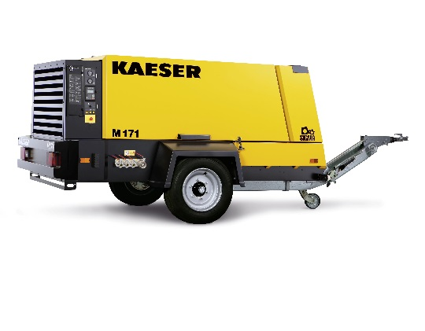
Kaeser’s new M171 portable compressor offers power and versatility
Download a high resolution image here.
Press Information Center
Contact us for contributions

FOR IMMEDIATE RELEASE
KAESER’S NEW M171 PORTABLE COMPRESSOR
Variable pressures from 85 to 205 psig
The new Mobilair™ M171 portable compressors delivers 405 to 600 cfm in variable pressures. With many rugged, durable features, it is ideal for heavy-duty civil and commercial construction, demolition, sand blasting and other site work applications.
The M171 comes standard with the Sigma Control Mobil controller which provides variable pressure ranges between 85 and 205 psig to power breakers, cable blowing and even high pressure applications. The controller also prevents improper shut-down, ensures machine-friendly start/stop operation and provides alerts for upcoming maintenance.
The M171 includes an easy-to-read but well-protected control panel, large-neck fuel tank with overflow protection. The heavy-duty steel chassis, galvanized steel canopy and solid steel flooring protect the Deutz diesel engine, Sigma Profile airend and motor. While the rugged tool bar and oversized tires allow for superior road handling. The high capacity, cold-start battery ensure reliable operation even under extreme weather conditions. Plus, the excellent cooling features allow the M171 to operate in temperatures up to 122° F.
For more information on the new M171 or our entire line of Mobilair portable compressors, visit us.kaeser.com/mobilair . For more information or to be connected with your local authorized Kaeser representative, please call (877) 596-7138.
About Kaeser: Kaeser is a leader in reliable, energy efficient compressed air equipment and system design. We offer a complete line of superior quality industrial air compressors as well as dryers, filters, SmartPipe™, master controls, and other system accessories. Kaeser also offers blowers, vacuum pumps, and portable gasoline and diesel screw compressors. Our national service network provides installation, rentals, maintenance, repair, and system audits. Kaeser is an ENERGY STAR Partner.
###

