Kaeser Compressors, Inc.
PO Box 946 Fredericksburg, VA 22404 USA
Phone: (540) 898-5500 us.kaeser.com

Press Contact: Michael Camber • (540) 684-9489
pr.us@kaeser.com

04/29/24
FOR IMMEDIATE RELEASE

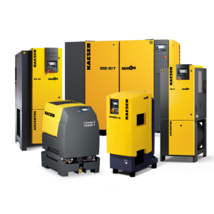 | KAirFree program extended to 100 hp with flows to 472 cfm  Download a high-resolution image here.
Expansion of KAirFree Program up to 100 hp

Kaeser Compressors, Inc. announces expansion of the KAirFree program with more options and even more flexibility.

Kaeser Compressors, Inc. today announced an expansion of its industry-leading KAirFree service to include 30, 50, and 100 horsepower options with guaranteed compressed air for a fixed monthly fee. This broader range of offerings provides even more businesses with the opportunity to benefit from KAirFree’s innovative service across a wider range. It also makes KAirFree suitable for a wider range of compressed air applications.

KAirFree programs include all services costs and eliminate concerns of reliability, air quality issues, unexpected downtime, and variable expenses associated with traditional compressed air ownership. Customers simply pay a monthly fee and Kaeser takes care of everything else, including installation, maintenance, and repairs. KAirFree is ideal for businesses that are expanding their operations, considering replacing outdated equipment, or testing out a new compressed air application.

“KAirFree is the fastest and easiest way to get compressed air,” said one satisfied KAirFree customer. “We chose KAirFree because of the flexibility it offers – we don't need to worry about the hassle and expense of owning and maintaining our own compressor.”

“With this expansion, we can now serve a broader range of compressed air users,” said Matt McCorkle, Manager of Branch Operations for Kaeser Compressors, Inc. “Whether you’re a growing business or looking for a more flexible solution, KAirFree offers a reliable and cost-effective way to get the compressed air you need.”

For more information, visit www.kairfree.com or call 800-777-7873.

###

About Kaeser Compressors, Inc.: Kaeser Compressors is a leader in reliable, energy efficient compressed air equipment and system design. We offer a complete line of superior quality industrial air compressors as well as dryers, filters, SmartPipe™, master controls, and other system accessories. Kaeser also offers blowers, vacuum pumps, and portable gasoline and diesel screw compressors. Our national service network provides installation, rentals, maintenance, repair, and system audits. Kaeser is an ENERGY STAR Partner.

