Kaeser Compressors, Inc.
PO Box 946 Fredericksburg, VA 22404 USA
Phone: (540) 898-5500 us.kaeser.com

Press Contact: Michael Camber • (540) 684-9489
pr.us@kaeser.com

6/21/2022
FOR IMMEDIATE RELEASE

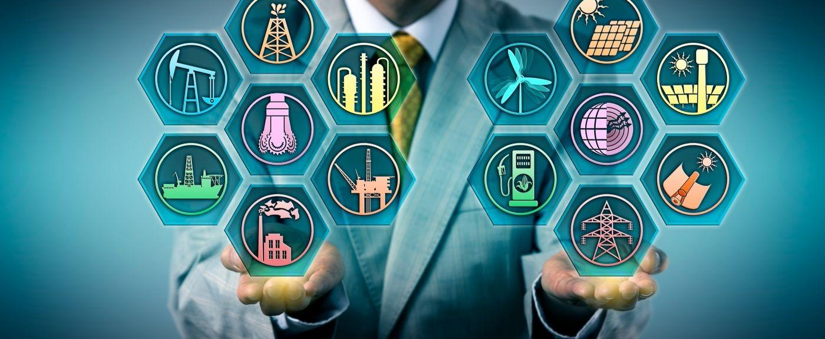 | Kaeser marks one year anniversary in using green energy for compressor manufacturing and US operations.  Download a high-resolution image here.

KAESER MARKS A FULL YEAR OF GREEN ENERGY

In an ongoing commitment to minimize environmental impacts, Kaeser is manufacturing with 100% green energy and matching our consumption with renewable energy resources.

Both Kaeser Compressors, Inc, in the US and Germany’s Kaeser Kompressoren SE are marking a full year of operations using only green energy. Not only are all Kaeser compressors manufactured with 100% renewable energy, Kaeser matches its consumption with renewable energy in both the US and Germany.

This milestone has been achieved with three key programs. First, over a year ago Kaeser Kompressoren SE installed a photovoltaic system which generates approximately 650 MWh for our main manufacturing plant in Coburg, Germany. Second, Kaeser purchases renewable energy credits for our remaining manufacturing facilities. And third, in the US, Kaeser Compressors is part of Dominion Energy’s Green Power Program and pays a premium per kWh for the US headquarters in Fredericksburg, Virginia to match energy consumption with renewable resources. And for our 20+ branch locations across the country as well as our teleworkers, we purchase RECs (Renewable Energy Certificates) from Dominion Energy exceeding the amount of power consumed. Energy for the RECs is purchased from a broad range of renewable energy sources such as wind, solar, biomass, geothermal, hydropower, wave/tidal power, and landfill gas recovery.

These initiatives align with Kaeser’s ongoing commitment to reducing, and where possible, eliminating impact on our shared environment.

“Not only are our products and systems designed for exceptional energy efficiency and maximum environmental compatibility, but Kaeser also incorporates environmentally responsible practices in our everyday operations and in the design and selection of our facilities,” said Frank Mueller, president of Kaeser Compressors, Inc. “We are committed to lowering our carbon footprint by manufacturing with green energy, to support renewable energy through Dominion Energy’s Green Power Program, and to demonstrate community leadership in this immediate and sustainable way.”

For more information on our commitment to the environment, visit us.kaeser.com/goyellowbegreen. For more information on our products and services, or to be connected with your local authorized Kaeser representative, please call (877) 417-3527.

###

About Kaeser Compressors, Inc.: Kaeser Compressors is a leader in reliable, energy efficient compressed air equipment and system design. We offer a complete line of superior quality industrial air compressors as well as dryers, filters, SmartPipe™, master controls, and other system accessories. Kaeser also offers blowers, vacuum pumps, and portable gasoline and diesel screw compressors. Our national service network provides installation, rentals, maintenance, repair, and system audits. Kaeser is an ENERGY STAR Partner.

