PRESS RELEASE

11/01/2018
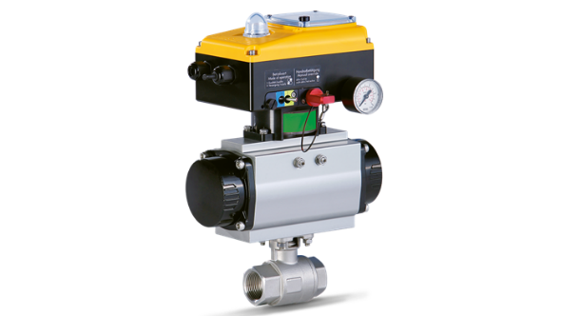
Kaeser’s new DHS electronic air main charging valve offers monitoring and alarm capabilities.
Download a high resolution image here.
Press Information Center
Contact us for contributions

FOR IMMEDIATE RELEASE
KAESER EXPANDS AMCV SERIES WITH NEW DHS
Removal of moisture, particulates and hydrocarbons from the compressed air system is vital in order to protect pneumatic equipment, minimize downtime, and reduce scrap and inferior product. The DHS helps ensure that dryers and filters perform to specification. This electronic intermediate control acts on a pressure signal to prevent high velocity conditions that will occur when system pressure is low. This maximizes contact time in air treatment components and makes them more effective. It also increases the bead and filter life of desiccant dryers by reducing dusting in the desiccant bed.
DHS units have high visibility LED indicators to communicate status at a glance. They can also be wired to dryers and drains so that in case these fail or are shut down, the DHS closes to prevent contamination from getting downstream. Users interested in remote monitoring/control can connect the DHS to plant monitoring systems or Kaeser Sigma Air Manager 4.0 if present.
DHS models are available in eight sizes from 1-inch ball to 8-inch butterfly valves to accommodate nearly any system.
For more information, visit us.kaeser.com. For more information or to be connected with your local authorized Kaeser representative, please call (877) 417-3527.
About Kaeser: Kaeser is a leader in reliable, energy efficient compressed air equipment and system design. We offer a complete line of superior quality industrial air compressors as well as dryers, filters, SmartPipe+™, master controls, and other system accessories. Kaeser also offers blowers, vacuum pumps, and portable screw compressors. Our national service network provides installation, rentals, maintenance, repair, and system audits. Kaeser is an ENERGY STAR Partner.
###

