PRESS RELEASE

09/04/2018
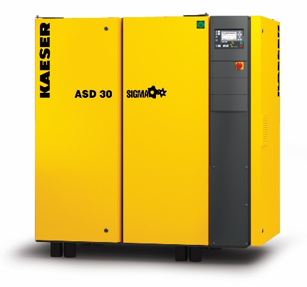
Kaeser’s upgraded ASD improves power 0.75% to 1.5%.
Download a high resolution image here.
Press Information Center
Contact us for contributions

FOR IMMEDIATE RELEASE
ANNOUNCING ASD SERIES PRODUCT UPGRADE
Kaeser Compressors’ newest improvements to our 25, 30 and 40hp direct drive compressors improve energy efficiency and longevity.
Kaeser has upgraded all ASD models with IE4 Super Premium efficiency drive motors. This motor decreases both power consumption and motor temperature. Specific power is improved from 0.75% to 1.5%, further reducing input kW. Cooler operating temperatures contribute to even better reliability and uptime.
The updated models include the standard 25, 30, and 40hp units, as well as the T-series with optional integral refrigerated dryers.
For more information, visit us.kaeser.com. For more information or to be connected with your local authorized Kaeser representative, please call (877) 417-3527.
About Kaeser: Kaeser is a leader in reliable, energy efficient compressed air equipment and system design. We offer a complete line of superior quality industrial air compressors as well as dryers, filters, SmartPipe™, master controls, and other system accessories. Kaeser also offers blowers, vacuum pumps, and portable gasoline and diesel screw compressors. Our national service network provides installation, rentals, maintenance, repair, and system audits. Kaeser is an ENERGY STAR Partner.
###

