03/10/2026
FOR IMMEDIATE RELEASE

NEW MOBILAIR M76 PORTABLE COMPRESSOR

New MOBILAIR M76 portable compressor offers pressure flexibility and all-day operation
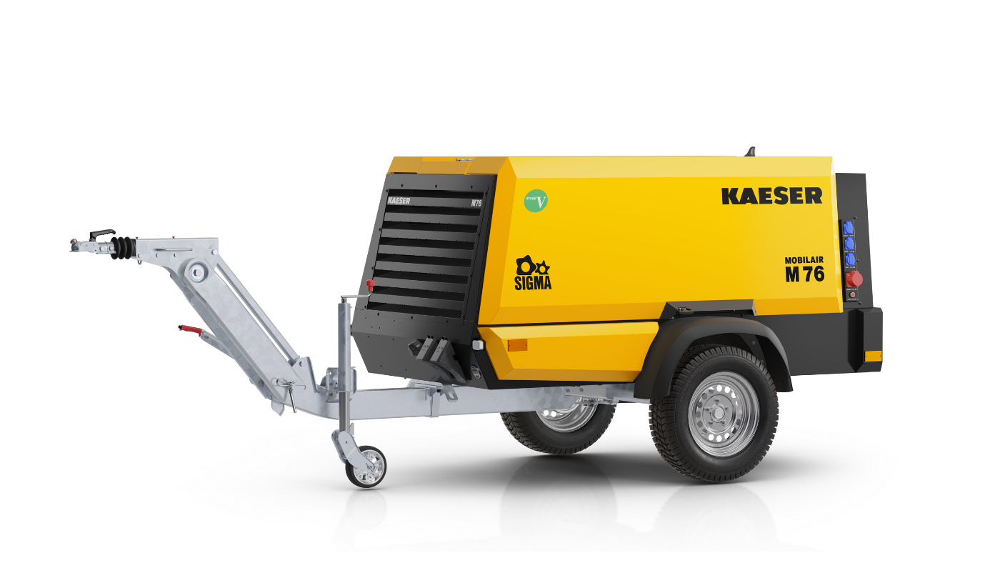
M76 portable compressor (European chassis pictured above) offers flows to 270 cfm, flexibility, and all-day operation

Download a high-resolution image here.
Kaeser Compressors, Inc. is proud to announce the new MOBILAIR M76 portable compressor, a versatile and rugged unit engineered for endurance. This addition to the Kaeser Mobilair line delivers flows up to 270 cfm.
The M76 features Kaeser's pV technology and provides superior pressure flexibility. Two variable pressure ranges (100-150 psig and 145-200 psig) allow users to easily adjust air pressure.
"With Kaeser's exclusive pV technology, included in the Sigma Control Smart compressor controller, you can easily adjust air pressure in 1 psi increments making this unit extremely versatile for many applications," said Chance Chartters, MOBILAIR Sales Manager.
At its heart is a heavy-duty, 4-cylinder Kubota diesel engine that meets Tier 4 Final EPA emissions standards. This rugged, fuel-efficient engine is integrated with an extra-large 34-gallon fuel tank to provide up to 9 hours of continuous operation on a single fuel fill. The M76 also features an energy-efficient Sigma Profile airend, a high-capacity cold-start battery, and an anti-frost valve that protects air tools from freezing up during cold weather usage.
Designed for easy maintenance and user-friendly operation, the M76 has large, wide-opening enclosure doors for ready access to all components. A lifting eye and a height-adjustable hitch with a rigid tow bar make transporting easy.
This new model is ideal for a variety of applications, including underground utilities, sandblasting, and general construction. The M76 is now available for order.
For more information, visit us.kaeser.com/mobilair. To be connected with your local authorized Kaeser representative, please call (877) 417-3527.

