05/08/2025
FOR IMMEDIATE RELEASE

KAESER BREAKS GROUND ON 80,000 SQ FT EXPANSION

Kaeser Compressors, Inc., the US headquarters of global compressor manufacturer Kaeser Kompressoren, SE, is expanding their facility in the Fredericksburg, Virginia area.
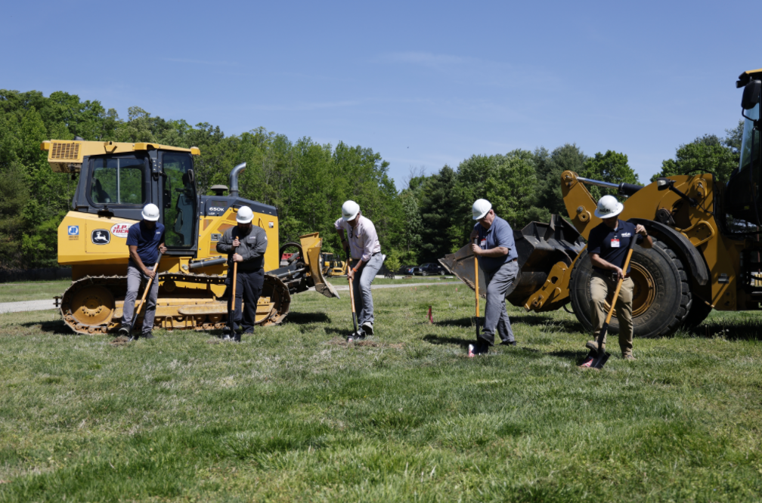
Left to right: Cedric Harrison, Matt Chilton, Frank Mueller (Kaesers Compressors, Inc.), Tyler Jennelle (Harlan Construction, and Michael Stevenson (McKinney and Co.)

Download a high-resolution image here.
Kaeser Compressors, Inc., the U.S. headquarters of global manufacturer Kaeser Kompressoren SE, broke ground on its newest facility expansion in Fredericksburg, Virginia, on April 29, 2025.
The ceremony marked the beginning of a new chapter for the company as it continues to grow its workforce and capabilities. Kaeser Compressors, Inc. President, Frank Mueller, led the event alongside representatives from Harlan Construction and McKinney & Company. Employees from the Fredericksburg office joined local and state officials and members of the press to celebrate the milestone.
“With this small shovel we’re going to seed Kaeser’s future growth,” said Mueller. “This project expands our capacity to build more of our custom engineered solutions and KASE units right here in Fredericksburg.”
The new space will primarily support the assembly of Kaeser’s custom air systems—complete compressed air, low-pressure blower, and vacuum systems engineered for high-performance installations. These systems are built for reliability, easy maintenance, and exceptional energy efficiency. Housed in rugged, weatherproof enclosures and mounted on custom skids, they significantly reduce installation time and costs by arriving fully assembled and ready to connect. While well-suited for mobile and temporary applications, they are also an ideal long-term solution for facilities with space, environmental, or installation constraints.
Kaeser currently employs nearly 300 people in the Fredericksburg area. This expansion is expected to create approximately 30 additional jobs across warehouse operations and the mechanical, electrical, and plumbing trades.
For more information, visit us.kaeser.com. To be connected with your local authorized Kaeser representative, please call (877) 417-3527.

