PRESS RELEASE

11/9/2021

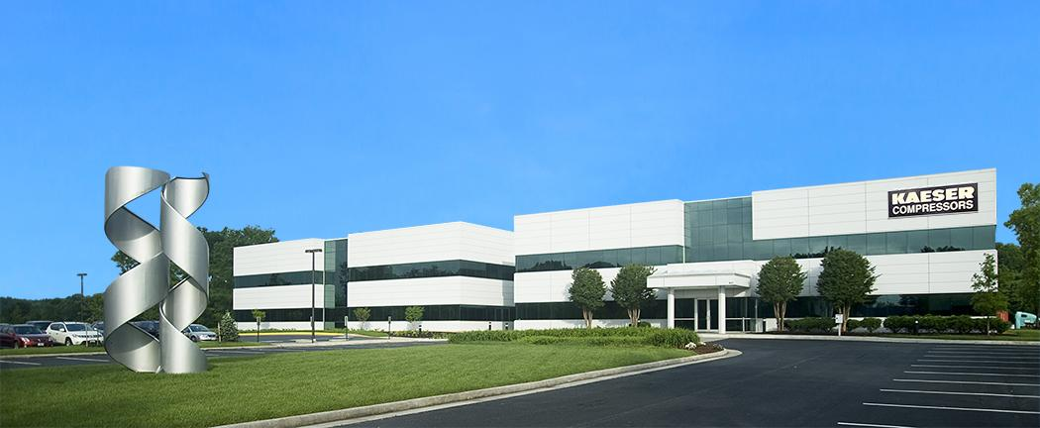 | Kaeser is now a UPS carbon neutral participant.  Press Information Center  Contact us for contributions.

FOR IMMEDIATE RELEASE

Kaeser Ships UPS carbon neutral

Fees for each shipment will be paid by Kaeser and used to invest in a variety of carbon offset programs.

Kaeser Compressors, Inc. is excited to be a participant in the UPS carbon neutral program. Kaeser will absorb the additional cost of each shipment without passing the fees on to our customers. The money generated will be used by UPS to invest in carbon offset programs.

Kaeser believes that maintaining the quality of our environment is a shared commitment. “Our products not only operate with exceptional energy efficiency and maximum environmental-compatibility but we also use natural resources as little as possible in production, sales and service,” said Frank Mueller, president of Kaeser Compressors, Inc. “The UPS carbon neutral program is an additional tool for Kaeser to operate more sustainably on a daily basis.”

Reliable offsets begin with accurate carbon calculations, and UPS calculates offsets based on actual shipping activity for envelopes, packages and freight. UPS’s offset purchases neutralize the calculated carbon impact from shipping by reducing it elsewhere. A certified, market-based financial instrument, carbon offsets are designed to mitigate greenhouse gas emission through reforestation, methane and landfill gas destruction, wastewater treatment and other programs.

For more information on Kaeser products or our commitment to the environment, visit us.kaeser.com. For more information or to be connected with your local authorized Kaeser representative, please call (877) 417-3527

###

About Kaeser Compressors, Inc.: Kaeser Compressors is a leader in reliable, energy efficient compressed air equipment and system design. We offer a complete line of superior quality industrial air compressors as well as dryers, filters, SmartPipe™, master controls, and other system accessories. Kaeser also offers blowers, vacuum pumps, and portable gasoline and diesel screw compressors. Our national service network provides installation, rentals, maintenance, repair, and system audits. Kaeser is an ENERGY STAR Partner.

